VISVESVARAYA TECHNOLOGICAL UNIVERSITY
“JnanaSangama”, Belgaum -590014, Karnataka.

LAB REPORT On
DATA STRUCTURES (23CS3PCDST)
Submitted by

CHAITHANYA J (1BM25CS430)
Under the Guidance of
Anusha S
Assistant Professor, BMSCE
in partial fulfillment for the award of the degree of
BACHELOR OF ENGINEERING
in
COMPUTER SCIENCE AND ENGINEERING


B.M.S. COLLEGE OF ENGINEERING
(Autonomous Institution under VTU)
BENGALURU-560019
August-December 2025
B. M. S. College of Engineering,
Bull Temple Road, Bangalore 560019
(Affiliated To Visvesvaraya Technological University, Belgaum)
Department of Computer Science and Engineering


This is to certify that the Lab work entitled “DATA STRUCTURES” carried out by CHAITHANYA J (1BM25CS430), who is bonafide student of B. M. S. College of Engineering. It is in partial fulfillment for the award of Bachelor of Engineering in Computer Science and Engineering of the Visvesvaraya Technological University, Belgaum during the year 20252026. The Lab report has been approved as it satisfies the academic requirements in respect of Data structures Lab - (23CS3PCDST) work prescribed for the said degree.

Prof. Anusha S | Dr. Kavitha Sooda
Assistant Professor | Professor and Head
Department of CSE | Department of CSE
BMSCE, Bengaluru | BMSCE, Bengaluru
Index Sheet

Sl.  No. | Experiment Title | Page No.
1 | Write a C Program to Perform Stack Operation. | 4-7
2 | Write a C Program to Convert Infix to Postfix Expression. | 7-10
3 | a)Write a C Program to Perform Queue Operation.  b)Perform Circular Queue. | 10-18
4 | a)Write a C Program to Perform Linked List(Delete Front, End, at the position).  b)Program- Leetcode Platform | 19-25
5 | a)Write a C Program to Perform Linked List(Delete Front, End, at the Position).  b)Program- Leetcode Platform | 25-33
6 | a)Reversing, Sorting, Concatenation on Linked List.  b)Implement Stack and Queue using Linked List. | 33-46
7 | a)Write a Program to Perform Doubly Linked List.  b)Program- Leetcode Platform | 47-59
8 | a)Write a Program to construct a binary Search tree.  b)Program – Leetcode Platform | 59-65
9 | a)Write a Program to traverse a graph using BFS method.  b)Write a program to check whether given graph is connected or not using DFS method. | 66-69
10 | Design and develop a Program in C that uses Hash Function. | 70-72

Course outcomes:
CO1 | Apply the concept of linear and nonlinear data structures.
CO2 | Analyze data structure operations for a given problem
CO3 | Design and develop solutions using the operations of linear and nonlinear data structure for a given specification.
CO4 | Conduct practical experiments for demonstrating the operations of different data structures.

Lab program 1:
Write a program to simulate the working of stack using an array with the following: a) Push
- Pop
- Display
The program should print appropriate messages for stack overflow, stack underflow.
#include <stdio.h>
void push();
void pop();
void peek();
int N=5;
int stack[5];
int top=-1;
int main()
{
int ch;
do
{
printf("Enter your choice:1(push/2(pop)/3(peek)/4(exit): /n");
scanf("%d",&ch);
switch(ch)
{
case 1:
push();
break;

case 2:
pop();
break;

case 3:
peek();
break;

case 4:
break;

default:
printf("Choice is out of range");
break;
}
}
while(ch!=4);
return 0;
}
void push()
{
int x;
printf("Enter data: ");
scanf("%d",&x);
if(top==N-1)
{
printf("overflow,cannot enter data\n");
}
else
{
top++;
stack[top]=x;
}
}
void pop()
{
int item;
if (top==-1)
{
printf("underflow,stack is empty\n");
}
else
{
item=stack[top];
top--;
printf("%d",item);
printf("\n");
}
}
void peek()
{
if(top==-1)
{
printf("underflow,\n");
}
else
{
printf("%d",stack[top]);
printf("\n");
}
}

Output:
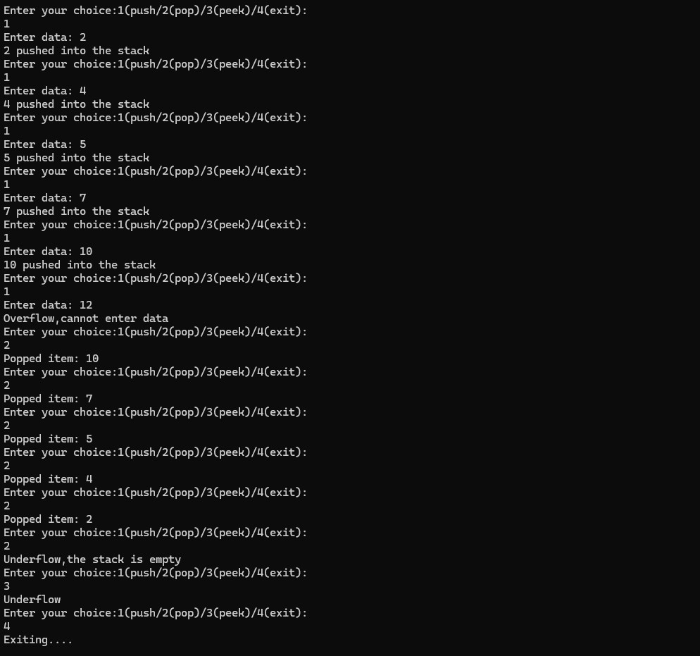

Lab program 2:
WAP to convert a give valid parenthesized infix arithmetic expression to postfix expression. The expression consists of single character operands and the binary operators +(plus), -(minus), *(multiply) and /(divide).

#include<stdio.h>
#include<ctype.h>
#include<string.h>
# define MAX 100
char stack[MAX];
int top=-1;
void push(char c){
if(top==MAX -1){
printf("Stack Overflow\n");
return ;
}
stack[++top]=c;
}
char pop(){
if(top==-1){
printf("stack Underflow\n");
return -1;
}
return stack[top--];
}
char peek(){
if(top==-1)return -1;
return stack[top];
}
int precedence(char op){
switch (op){
case '+':
case '-':
return 1;
case '*':
case '/':
return 2;
case '^':return 3;
case '(':
return 0;

}
return -1;
}
int associativity(char op){
if(op=="^")
return 1;
return 0;
}
void infixTopostfix(char infix[],char postfix[]){
int i,k=0;
char c;
for (i=0;infix[i]!='\0';i++){
c=infix[i];
if (isalnum(c)){
postfix[k++]=c;
}
else if(c=='('){
push(c);
}
else if(c==')'){
while (peek()!='('){
postfix[k++]=pop();
}
pop();
}
else{
while (top !=-1&&((precedence(peek()) > precedence(c))||(precedence(peek()) == precedence(c))&& associativity(c)==0)){
postfix[k++]=pop();
}
push(c);
}
}
while (top!=-1)
{postfix[k++]=pop();
/* code */
}
postfix[k]='\0';

}
int main() {
char infix[MAX],postfix[MAX];
printf("enter a valid parantesiczed infix expression: ");
scanf("%s",infix);
infixTopostfix(infix,postfix);
printf("Postfix expre:%s\n",postfix);
return 0;

}

Output:
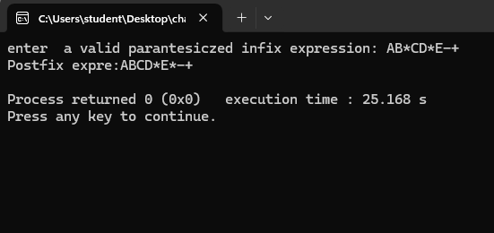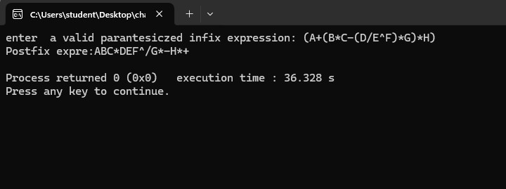

Lab Program 3a:
WAP to simulate the working of a queue of integers using an array. Provide the following operations: Insert, Delete, Display The program should print appropriate messages for queue empty and queue overflow conditions

#include <stdio.h>
#define N 5

int queue[N];
int front=-1,rear=-1;

void enqueue(int x) {
if (rear==N-1) {
printf("Queue overflow\n");
}
else if(front==-1 && rear==-1) {
front=rear=0;
queue[rear]=x;
}
else {
rear++;
queue[rear]=x;
}
}

void dequeue() {
if (front==-1 && rear==-1){
printf("Queue is empty\n");
}
else if(front==rear){
printf("Deleted element is: %d\n",queue[front]);
front=rear=-1;
}
else{
printf("Deleted element is: %d\n",queue[front]);
front++;
}
}

void display() {
if (front==-1 && rear==-1){
printf("Queue is empty\n");
}
else {
printf("Queue elements are:\n");
for(int i=front;i<=rear;i++){
printf("%d ",queue[i]);
}
printf("\n");
}
}

void peek(){
if (front==-1 && rear==-1){
printf("Queue is empty\n");
}
else{
printf("Front element: %d\n",queue[front]);
}
}

int main() {
int choice,x;

do{
printf("\n1.Enqueue\n");
printf("2.Dequeue\n");
printf("3.Display\n");
printf("4.Peek\n");
printf("5.Exit\n");
printf("Enter your choice: ");
scanf("%d",&choice);

switch(choice) {
case 1:
printf("Enter element to insert: ");
scanf("%d",&x);
enqueue(x);
break;

case 2:
dequeue();
break;

case 3:
display();
break;

case 4:
peek();
break;

case 5:
printf("Exiting....\n");
break;

default:
printf("Invalid Choice\n");
}
}
while (choice !=5);
return 0;
}

Output:
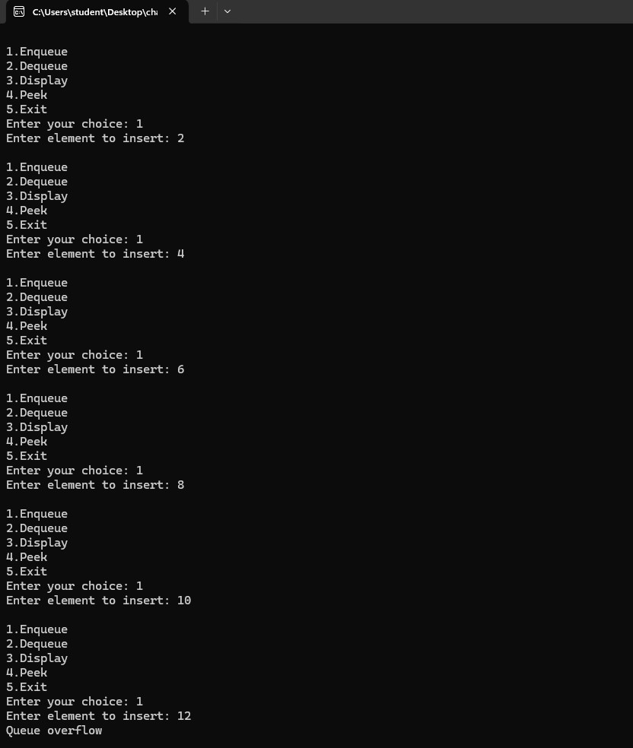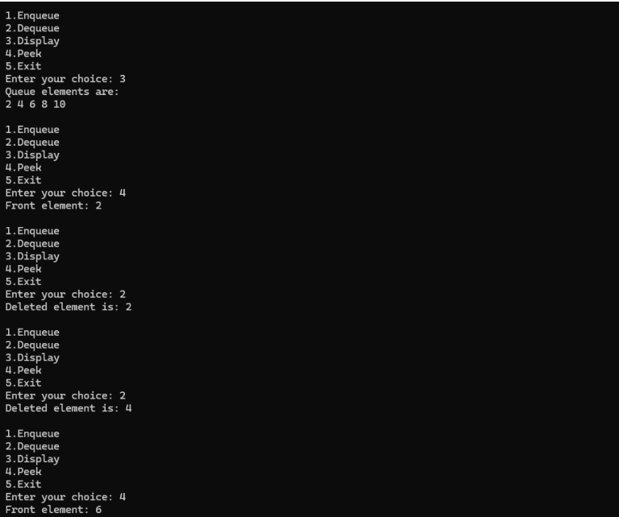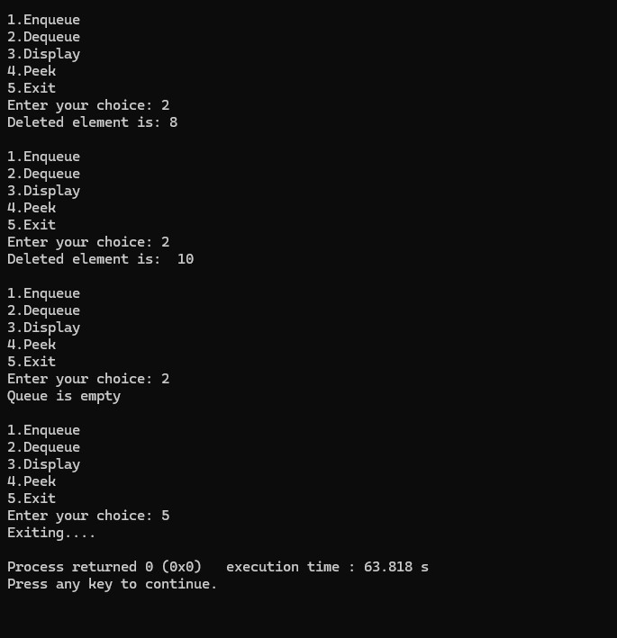

Lab Program 3b:
WAP to simulate the working of a circular queue of integers using an array. Provide the following operations: Insert, Delete & Display The program should print appropriate messages for queue empty and queue overflow conditions.

#include <stdio.h>
#define N 5

int queue[N];
int front=-1,rear=-1;

void enqueue(int x) {
if(front==-1 && rear==-1) {
front=rear=0;
queue[rear]=x;
printf("Inserted element %d into the queue\n",queue[rear]);
}
else if((rear+1)%N==front){
printf("Queue is full\n");
}
else {
rear=(rear+1)%N;
printf("Inserted element %d into the queue\n",x);
queue[rear]=x;
}
}

void dequeue() {
if (front==-1 && rear==-1){
printf("Queue is empty\n");
}
else if(front==rear){
printf("Deleted element is: %d\n",queue[front]);
front=rear=-1;
}
else{
printf("Deleted element is: %d\n",queue[front]);
front=(front+1)%N;
}
}

void display() {
if (front==-1 && rear==-1){
printf("Queue is empty\n");
}
else {
printf("Queue elements are:\n");
int i;
for (i = front; i !=rear; i=(i + 1) % N)
{
printf("%d ", queue[i]);
}
printf("%d ", queue[i]);
}
printf("\n");
}

int main() {
int choice,x;

do{
printf("\n1.Enqueue\n");
printf("2.Dequeue\n");
printf("3.Display\n");
printf("4.Exit\n");
printf("Enter your choice: ");
scanf("%d",&choice);

switch(choice) {
case 1:
printf("Enter element to insert: ");
scanf("%d",&x);
enqueue(x);
break;

case 2:
dequeue();
break;

case 3:
display();
break;

case 4:
printf("Exiting....\n");
break;

default:
printf("Invalid Choice\n");
}
}
while (choice !=4);
return 0;
}

Output:
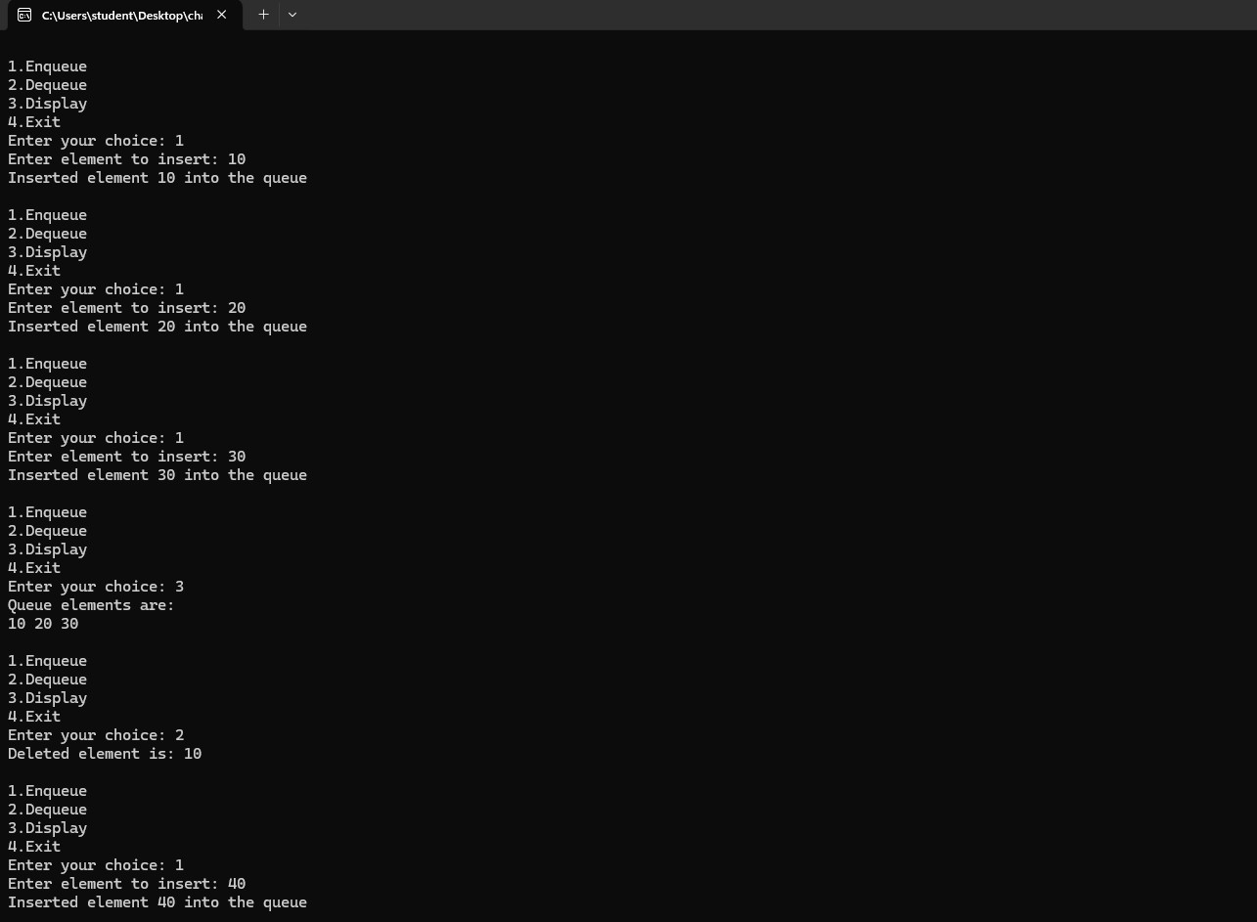
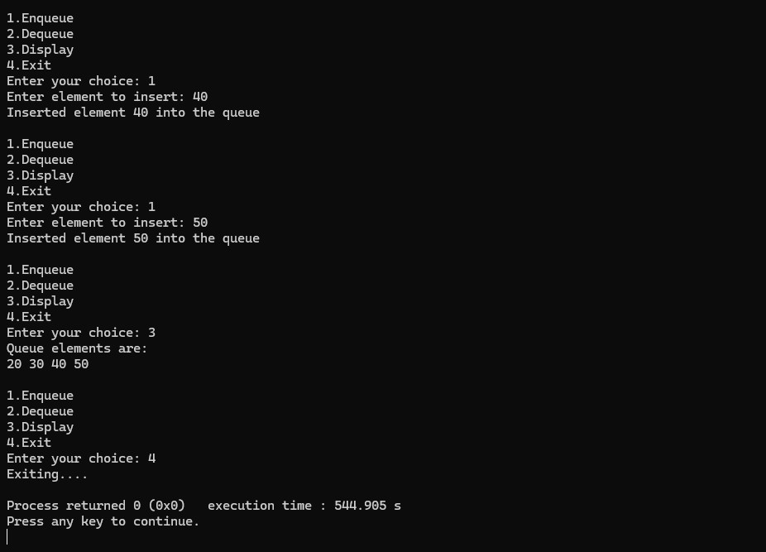

Lab Program 4:
WAP to Implement Singly Linked List with following operations a) Create a linked list. b) Insertion of a node at first position, at any position and at end of list. Display the contents of the linked list.

#include <stdio.h>
#include <stdlib.h>

// Structure to represent a node
struct Node {
int data;
struct Node *next;
};

struct Node *head = NULL;

// Function to create a linked list
void createList(int n) {
struct Node *newNode, *temp;
int data, i;

if (n <= 0) {
printf("Number of nodes should be greater than 0.\n");
return;
}

for (i = 1; i <= n; i++) {
newNode = (struct Node *)malloc(sizeof(struct Node));
if (newNode == NULL) {
printf("Memory allocation failed.\n");
return;
}

printf("Enter data for node %d: ", i);
scanf("%d", &data);

newNode->data = data;
newNode->next = NULL;

if (head == NULL) {
head = newNode; // first node
} else {
temp->next = newNode; // link new node
}

temp = newNode; // move temp to last node
}

printf("\nLinked list created successfully.\n");
}

// Function to insert at beginning
void insertAtBeginning(int data) {
struct Node *newNode = (struct Node*)malloc(sizeof(struct Node));
newNode->data = data;
newNode->next = head;
head = newNode;
printf("Node inserted at the beginning.\n");
}

// Function to insert at end
void insertAtEnd(int data) {
struct Node *newNode = (struct Node*)malloc(sizeof(struct Node));
newNode->data = data;
newNode->next = NULL;

if (head == NULL) {
head = newNode;
} else {
struct Node *temp = head;
while (temp->next != NULL)
temp = temp->next;
temp->next = newNode;
}

printf("Node inserted at the end.\n");
}

// Function to insert at any position
void insertAtPosition(int data, int pos) {
int i;
struct Node *newNode, *temp = head;

if (pos < 1) {
printf("Invalid position.\n");
return;
}

if (pos == 1) {
insertAtBeginning(data);
return;
}

newNode = (struct Node*)malloc(sizeof(struct Node));
newNode->data = data;

for (i = 1; i < pos - 1 && temp != NULL; i++)
temp = temp->next;

if (temp == NULL) {
printf("Position out of range.\n");
free(newNode);
} else {
newNode->next = temp->next;
temp->next = newNode;
printf("Node inserted at position %d.\n", pos);
}
}

void displayList(){
struct Node*temp = head;
if (head==NULL){
printf("List is empty.\n");
return;
}
printf("\nLinked List: ");
while(temp!=NULL){
printf("%d->",temp->data);
temp=temp->next;
}
printf("Null\n");
}

int main(){
int choice,n,data,pos;

while(1){
printf("\n----SINGLY LINKED LIST OPERATIONS----\n");
printf("1.Create linked list\n");
printf("2.Insert at beginning\n");
printf("3.Insert at any position\n");
printf("4.Insert at end\n");
printf("5.Display list\n");
printf("6.Exit\n");
printf("Enter your choice: ");
scanf("%d",&choice);

switch(choice) {
case 1:
printf("Enter number of nodes: ");
scanf("%d",&n);
createList(n);
break;

case 2:
printf("Enter data to insert: ");
scanf("%d",&data);
insertAtBeginning(data);
break;

case 3:
printf("Enter data and position: ");
scanf("%d %d",&data,&pos);
insertAtPosition(data,pos);
break;

case 4:
printf("Enter data to insert: ");
scanf("%d",&data);
insertAtEnd(data);
break;

case 5:
displayList();
break;

case 6:
printf("Exiting....\n");
exit(0);

default:
printf("Invalid Choice\n");
}
}
return 0;
}

Output:
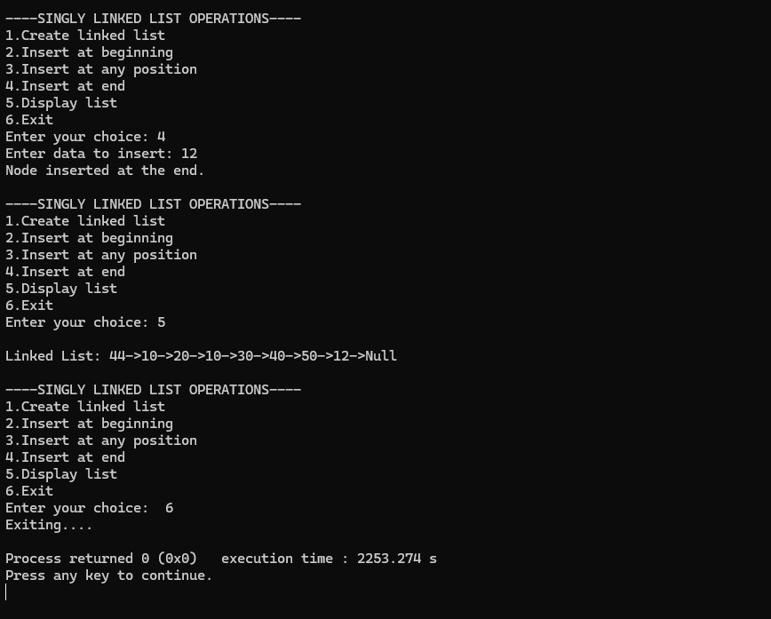
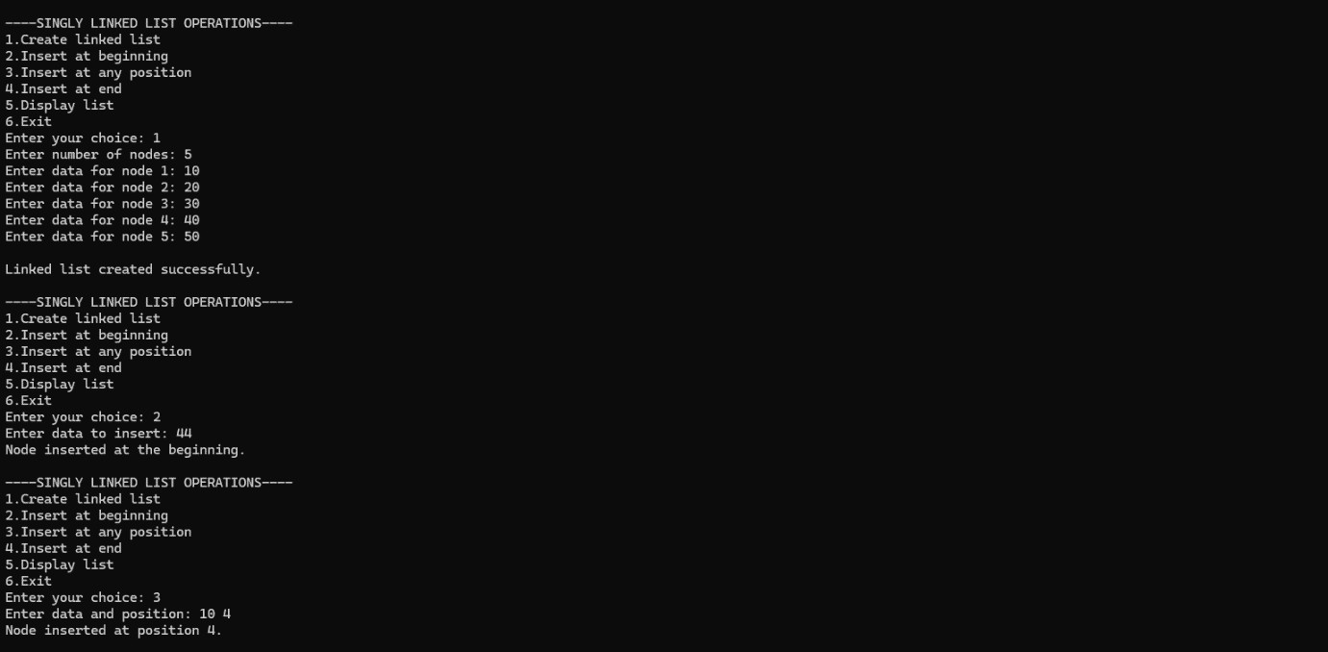

Lab Program 4b:
Leetcode Platform

struct ListNode* middleNode(struct ListNode* head) {
struct ListNode* slow = head;
struct ListNode* fast = head;

// Fast moves two steps, slow moves one step
while (fast != NULL && fast->next != NULL) {
slow = slow->next;
fast = fast->next->next;
}

return slow;
}
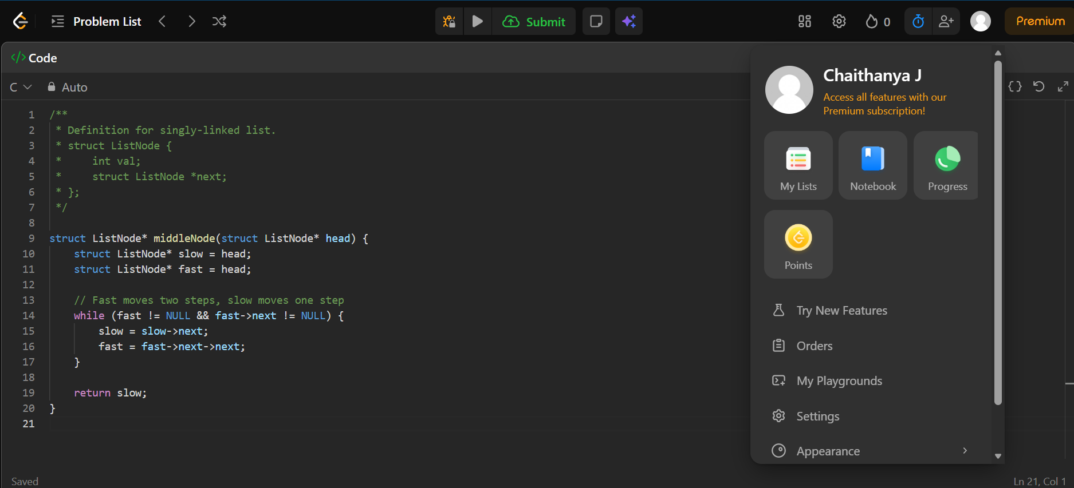

Output:
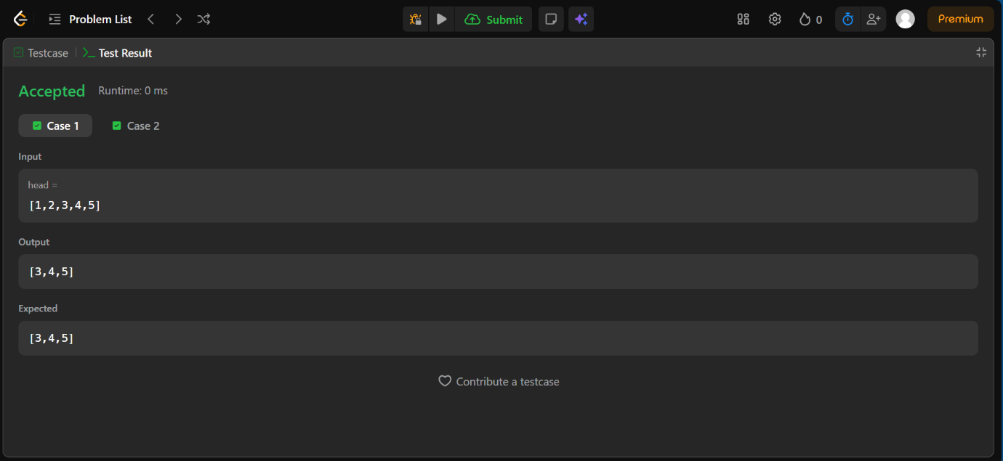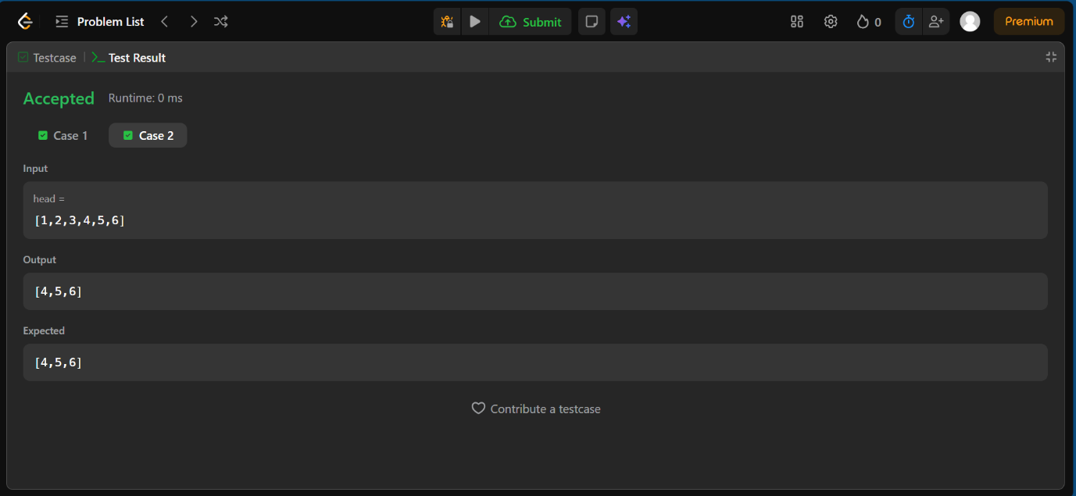

Lab Program 5a:
WAP to Implement Singly Linked List with following operations
a) Create a linked list.
b) Deletion of first element, specified element and last element in the list.
c) Display the contents of the linked list.

#include<stdio.h>
#include<stdlib.h>
struct Node{
int data;
struct Node *next;
};
struct Node *head=NULL;
void createList(int n){
struct Node *newNode,*temp;
int data,i;
if(n<=0){printf("Number of nodes should be greater than 0\n");
return ;}
for(i=1;i<=n;i++)
{
newNode=(struct Node *)malloc(sizeof(struct Node));
if(newNode==NULL){
printf("Memory allocation failed\n");
return;
}
printf("Enter data for node %d: ",i);
scanf("%d",&data);
newNode ->data=data;
newNode->next=NULL;
if(head==NULL){
head=newNode;
}
else{
temp->next=newNode;
}
temp=newNode;
}
printf("\nLinked list created successfully\n");
}
void deleteFirst(){
struct Node *temp;
if(head==NULL){
printf("List is empty.Nothing to delete.\n");
return;
}
temp=head;
head=head->next;
printf("Deleted element:%d\n",temp->data);
free(temp);
}

void deleteLast(){
struct Node *temp,*prev;
if(head==NULL){
printf("List is empty .Nothing to delete\n");
return;
}
temp=head;
while(temp->next!=NULL){
prev=temp;
temp=temp->next;
}
printf("Deleted element:%d\n",temp->data);
prev->next=NULL;
free(temp);
}

void deleteSpecific(int value){
struct Node *temp=head,*prev=NULL;
if(head==NULL){
printf("List is empty .Nothing to delete\n");
return;
}
if(head->data==value){
head=head->next;
printf("Deleted element:%d\n",temp->data);
free(temp);
return;
}
while(temp!=NULL && temp->data!=value){
prev=temp;
temp=temp->next;
}
if (temp == NULL) {
printf("Element %d not found in the list\n", value);
return;
}

prev->next = temp->next;
printf("Deleted element:%d\n", temp->data);
free(temp);
}

void displayList(){
struct Node *temp=head;
if(head==NULL){
printf("List is empty\n");
}
printf("\nLinked List: ");
while (temp!=NULL){
printf("%d -> ",temp->data);
temp=temp->next;
}
printf("NULL");
}

int main(){
int choice,n,value;
while(1){
printf("\n---Singly Linked List Operations---\n");
printf("1.Create Linked List\n"
"2.Delete First Element\n"
"3.Delete Specific Element\n"
"4.Delete Last Element\n"
"5.Display\n"
"6.Exit\n");

printf("Enter your choice: ");
scanf("%d",&choice);
switch(choice){
case 1:printf("Enter num of nodes: ");
scanf("%d" ,&n);
createList(n);
break;
case 2:
deleteFirst();
break;
case 3:printf("Enter value to delete: ");
scanf("%d",&value);
deleteSpecific(value);
break;
case 4:

deleteLast();break;
case 5:
displayList();
break;
case 6:printf("Exiting program\n");
exit(0);

default:printf("Invalid choice Try again\n");
}
}
return 0;
}

Output:
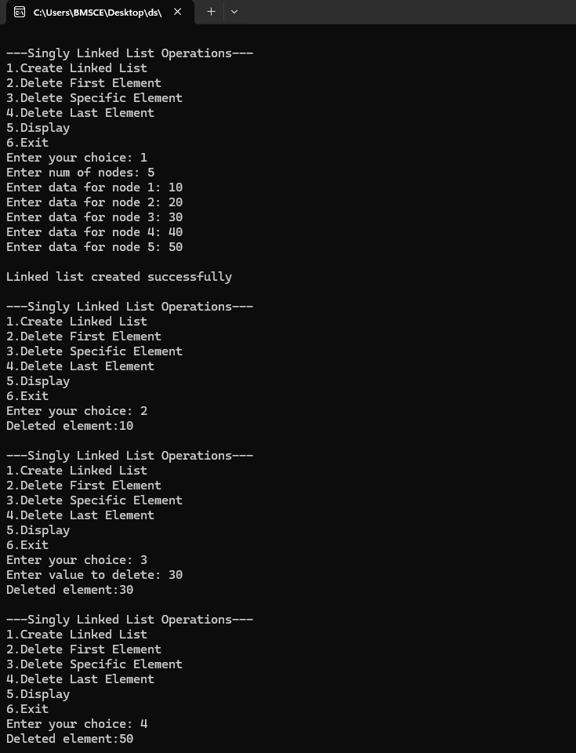
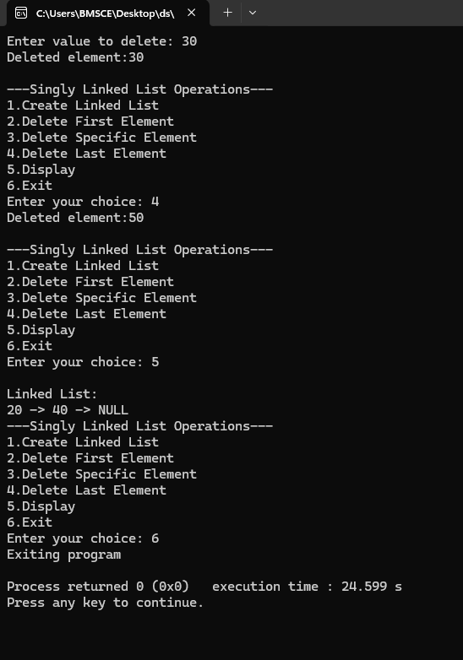

Lab Program 5b:
Leetcode platform

struct ListNode* removeElements(struct ListNode* head, int val) {
// Create a dummy node pointing to head
struct ListNode* dummy = (struct ListNode*)malloc(sizeof(struct ListNode));
dummy->next = head;

struct ListNode* prev = dummy;
struct ListNode* curr = head;

while (curr != NULL) {
if (curr->val == val) {
// Skip this node
prev->next = curr->next;
free(curr);
curr = prev->next;
} else {
prev = curr;
curr = curr->next;
}
}

struct ListNode* newHead = dummy->next;
free(dummy);
return newHead;
}
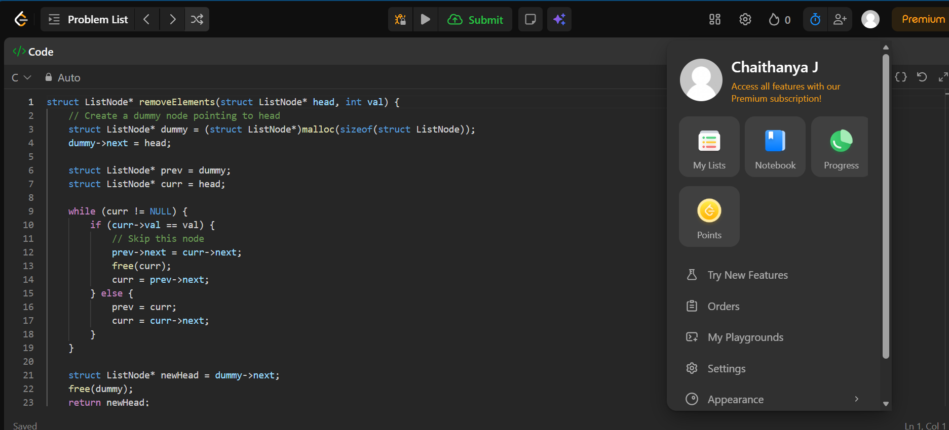

Output:
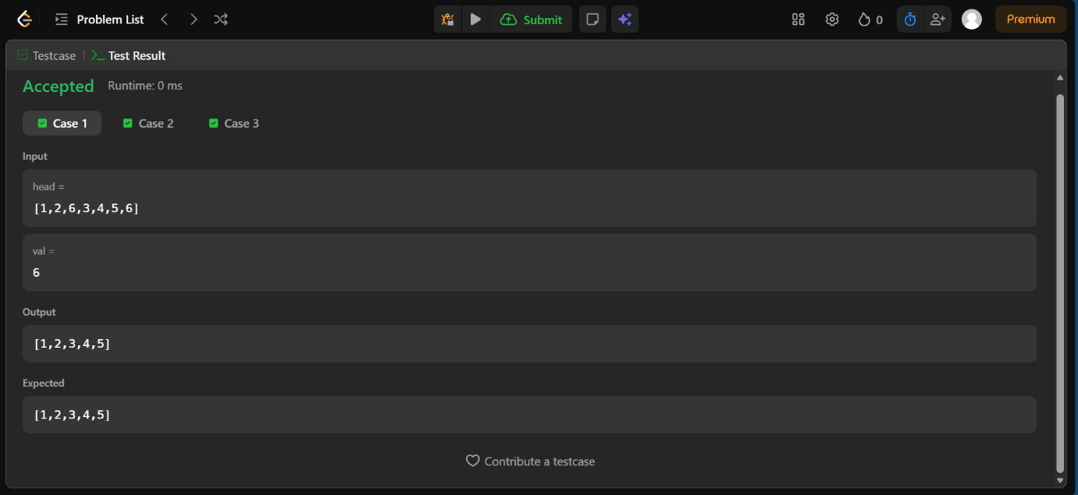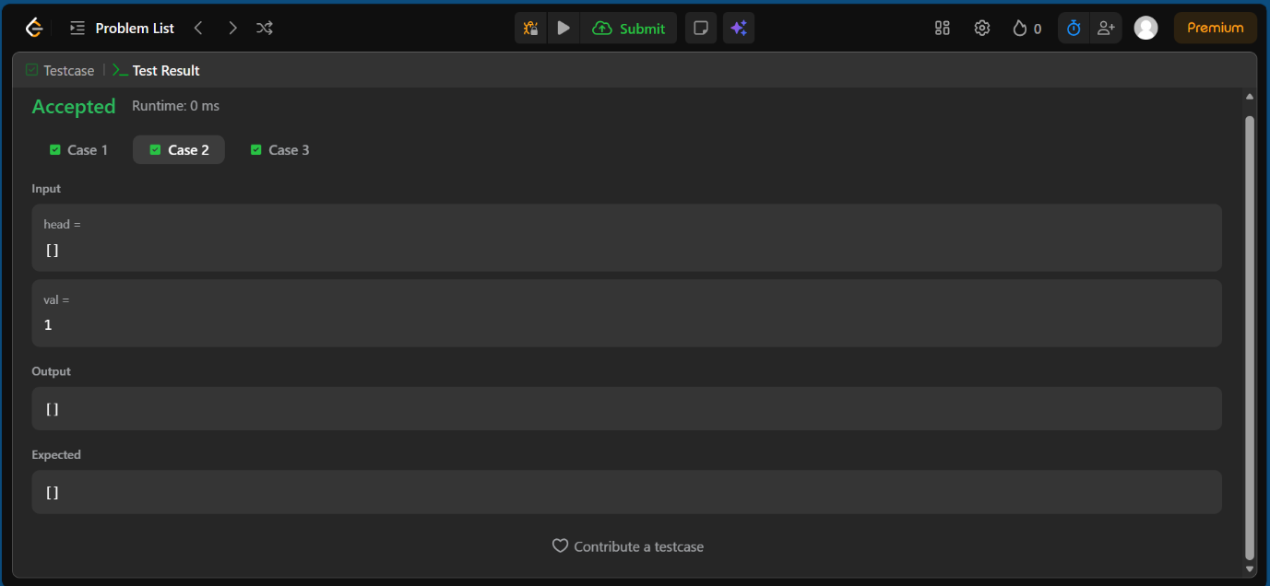
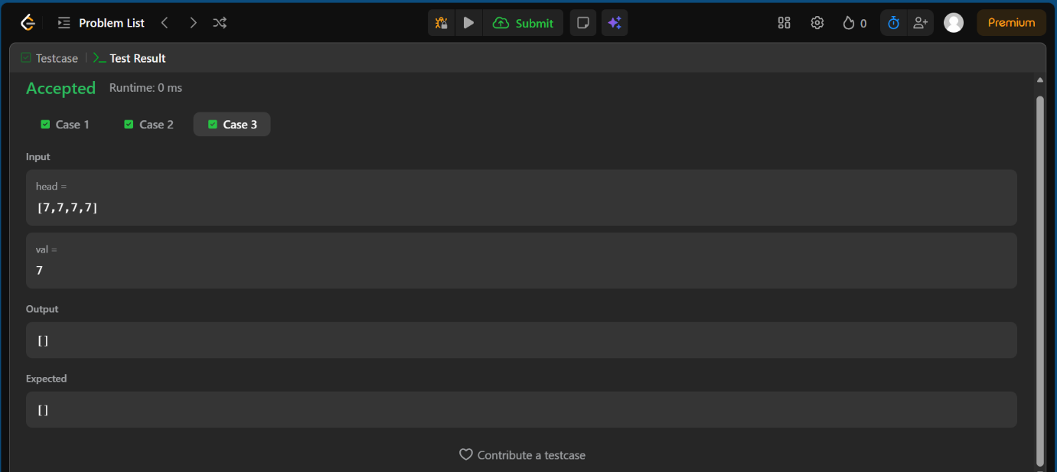

Lab Program 6a:
WAP to Implement Single Link List with following operations: Sort the linked list, Reverse the linked list, Concatenation of two linked lists.

#include <stdio.h>
#include <stdlib.h>

struct Node {
int data;
struct Node *next;
};

// Global heads
struct Node *head1 = NULL;
struct Node *head2 = NULL;

// Function prototypes
struct Node* createList(int n);
void displayList(struct Node *head);
void sortLinkedList(struct Node *head);
struct Node* reverseLinkedList(struct Node *head);
struct Node* concatenateLinkedList(struct Node *head1, struct Node *head2);

// Create list
struct Node* createList(int n) {
struct Node *head = NULL, *newNode, *temp;
int data;

if (n <= 0) {
printf("Number of nodes should be greater than 0\n");
return NULL;
}

for (int i = 1; i <= n; i++) {
newNode = (struct Node*)malloc(sizeof(struct Node));
if (newNode == NULL) {
printf("Memory allocation failed\n");
return head;
}

printf("Enter data for node %d: ", i);
scanf("%d", &data);

newNode->data = data;
newNode->next = NULL;

if (head == NULL)
head = newNode;
else
temp->next = newNode;

temp = newNode;
}

printf("Linked list created successfully\n");
return head;
}

// Display
void displayList(struct Node *head) {
struct Node *temp = head;

if (head == NULL) {
printf("List is empty\n");
return;
}

printf("Linked List: ");
while (temp != NULL) {
printf("%d -> ", temp->data);
temp = temp->next;
}
printf("NULL\n");
}

// Sort
void sortLinkedList(struct Node *head) {
struct Node *i, *j;
int tempData;

if (head == NULL) {
printf("List is empty, cannot sort.\n");
return;
}

for (i = head; i->next != NULL; i = i->next) {
for (j = i->next; j != NULL; j = j->next) {
if (i->data > j->data) {
tempData = i->data;
i->data = j->data;
j->data = tempData;
}
}
}

printf("Linked list sorted successfully\n");
}

// Reverse
struct Node* reverseLinkedList(struct Node *head) {
struct Node *prev = NULL, *curr = head, *next = NULL;

while (curr != NULL) {
next = curr->next;
curr->next = prev;
prev = curr;
curr = next;
}

printf("Linked list reversed successfully\n");
return prev;
}

// Concatenate
struct Node* concatenateLinkedList(struct Node *head1, struct Node *head2) {
struct Node *temp;

if (head1 == NULL)
return head2;

temp = head1;
while (temp->next != NULL)
temp = temp->next;

temp->next = head2;

printf("Linked lists concatenated successfully\n");
return head1;
}

// Menu
int main() {
int choice, n;

while (1) {
printf("\n===============================\n");
printf(" LINKED LIST MENU \n");
printf("===============================\n");
printf("1. Create List 1\n");
printf("2. Create List 2\n");
printf("3. Display List 1\n");
printf("4. Display List 2\n");
printf("5. Sort List 1\n");
printf("6. Reverse List 1\n");
printf("7. Concatenate List 1 + List 2\n");
printf("8. Exit\n");
printf("Enter choice: ");
scanf("%d", &choice);

switch (choice) {
case 1:
printf("Enter number of nodes for List 1: ");
scanf("%d", &n);
head1 = createList(n);
break;

case 2:
printf("Enter number of nodes for List 2: ");
scanf("%d", &n);
head2 = createList(n);
break;

case 3:
displayList(head1);
break;

case 4:
displayList(head2);
break;

case 5:
sortLinkedList(head1);
break;

case 6:
head1 = reverseLinkedList(head1);
break;

case 7:
head1 = concatenateLinkedList(head1, head2);
printf("After concatenation:\n");
displayList(head1);
break;

case 8:
printf("Exiting program...\n");
exit(0);

default:
printf("Invalid choice. Try again.\n");
}
}

return 0;
}

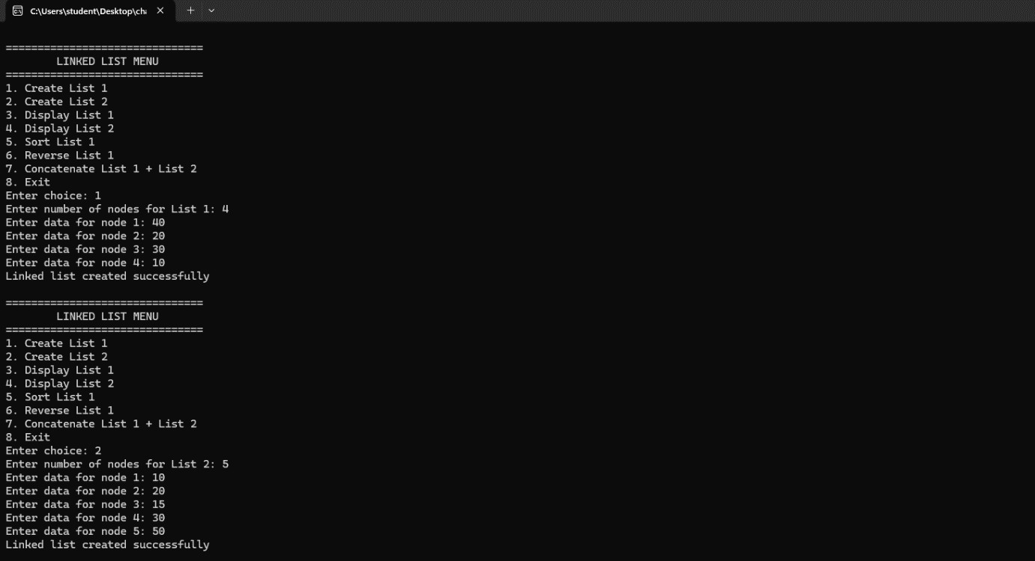
Output:

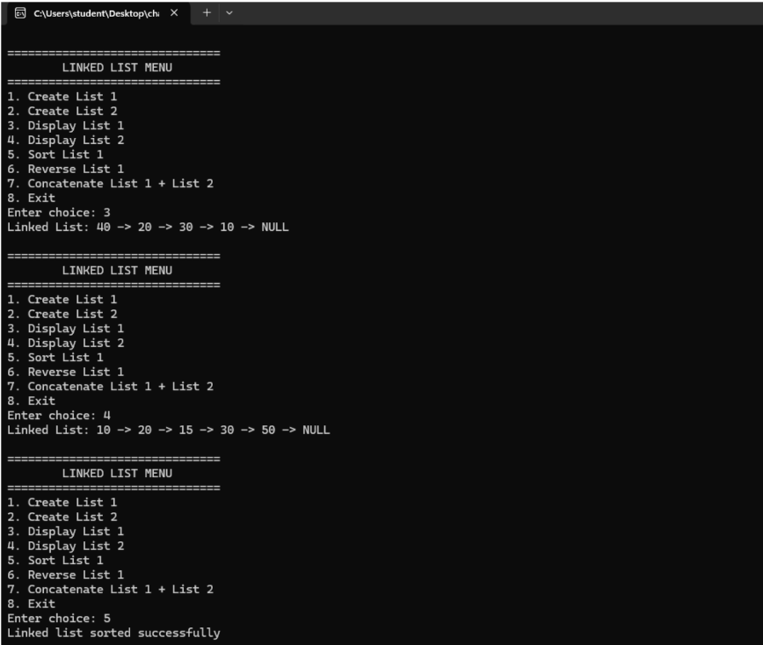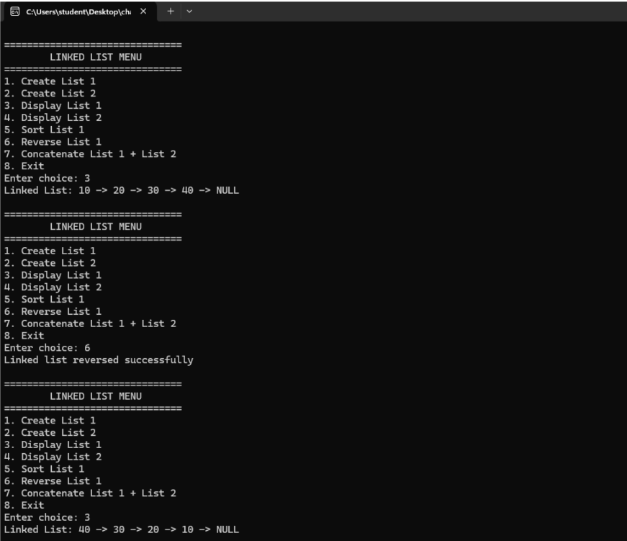

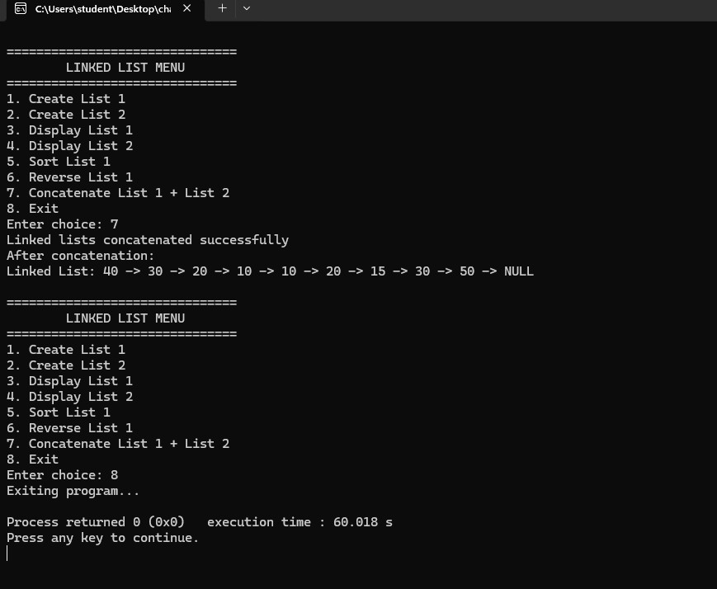

Lab Program 6b:
WAP to Implement Single Link List to simulate Stack & Queue Operations.

#include <stdio.h>
#include <stdlib.h>

struct Node {
int data;
struct Node *next;
};

// Stack pointers
struct Node *top = NULL;

// Queue pointers
struct Node *front = NULL;
struct Node *rear = NULL;

// Function to create a new node
struct Node* createNode(int value) {
struct Node *newNode = (struct Node*)malloc(sizeof(struct Node));
if (!newNode) {
printf("Memory allocation failed!\n");
exit(0);
}
newNode->data = value;
newNode->next = NULL;
return newNode;
}

/////////////////////////////////////////////////////////////
// STACK OPERATIONS //
/////////////////////////////////////////////////////////////

// PUSH
void push(int value) {
struct Node *newNode = createNode(value);
newNode->next = top;
top = newNode;
printf("Pushed: %d\n", value);
}

// POP
void pop() {
if (top == NULL) {
printf("Stack Underflow!\n");
return;
}
struct Node *temp = top;
printf("%d popped from the stack\n", temp->data);
top = top->next;
free(temp);
}

// DISPLAY STACK
void displayStack() {
struct Node *temp = top;
if (temp== NULL) {
printf("Stack is Empty!\n");
return;
}

printf("Stack (top to bottom) elements are: ");
while (temp!= NULL) {
printf("%d ", temp->data);
temp=temp->next;
}
printf("\n");
}

/////////////////////////////////////////////////////////////
// QUEUE OPERATIONS //
/////////////////////////////////////////////////////////////

// ENQUEUE
void enqueue(int value) {
struct Node *newNode = createNode(value);

if (front == NULL) {
front = rear = newNode;
} else {
rear->next = newNode;
rear = newNode;
}

printf("%d enqueued to the queue\n", value);
}

// DEQUEUE
void dequeue() {
if (front == NULL) {
printf("Queue is empty\n");
return;
}

struct Node *temp = front;
printf("%d dequeued from queue\n", temp->data);

front = front->next;
if (front == NULL)
rear = NULL;

free(temp);
}

// DISPLAY QUEUE
void displayQueue() {
struct Node *temp = front;
if (temp == NULL) {
printf("Queue is Empty!\n");
return;
}

printf("Queue (front to rear) elements are: ");
while (temp!= NULL) {
printf("%d ", temp->data);
temp=temp->next;
}
printf("\n");
}

/////////////////////////////////////////////////////////////

int main() {
int choice, value, ch;

while (1) {
printf("\n--- Singly Linked List Simulation ---\n");
printf("1. Stack Operations\n");
printf("2. Queue Operations\n");
printf("3. Exit\n");
printf("Enter your choice: ");
scanf("%d", &choice);

switch (choice) {

// ---------------- STACK MENU ----------------
case 1:
while (1) {
printf("\n--- Stack Menu ---\n");
printf("1. Push\n");
printf("2. Pop\n");
printf("3. Display Stack\n");
printf("4. Back to Main Menu\n");
printf("Enter your choice: ");
scanf("%d", &ch);

switch (ch) {
case 1:
printf("Enter value to push: ");
scanf("%d", &value);
push(value);
break;

case 2:
pop();
break;

case 3:
displayStack();
break;

case 4:
goto main_menu;
default:
printf("Invalid Choice!\n");
}
}
break;

// ---------------- QUEUE MENU ----------------
case 2:
while (1) {
printf("\n--- Queue Menu ---\n");
printf("1. Enqueue\n");
printf("2. Dequeue\n");
printf("3. Display Queue\n");
printf("4. Back to Main Menu\n");
printf("Enter your choice: ");
scanf("%d", &ch);

switch (ch) {
case 1:
printf("Enter value to enqueue: ");
scanf("%d", &value);
enqueue(value);
break;

case 2:
dequeue();
break;

case 3:
displayQueue();
break;

case 4:
goto main_menu;
default:
printf("Invalid Choice!\n");
}
}
break;

// ---------------- EXIT ----------------
case 3:
printf("Exiting....\n");
exit(0);

default:
printf("Invalid choice!\n");
}
main_menu: ;
}
return 0;
}

Output:
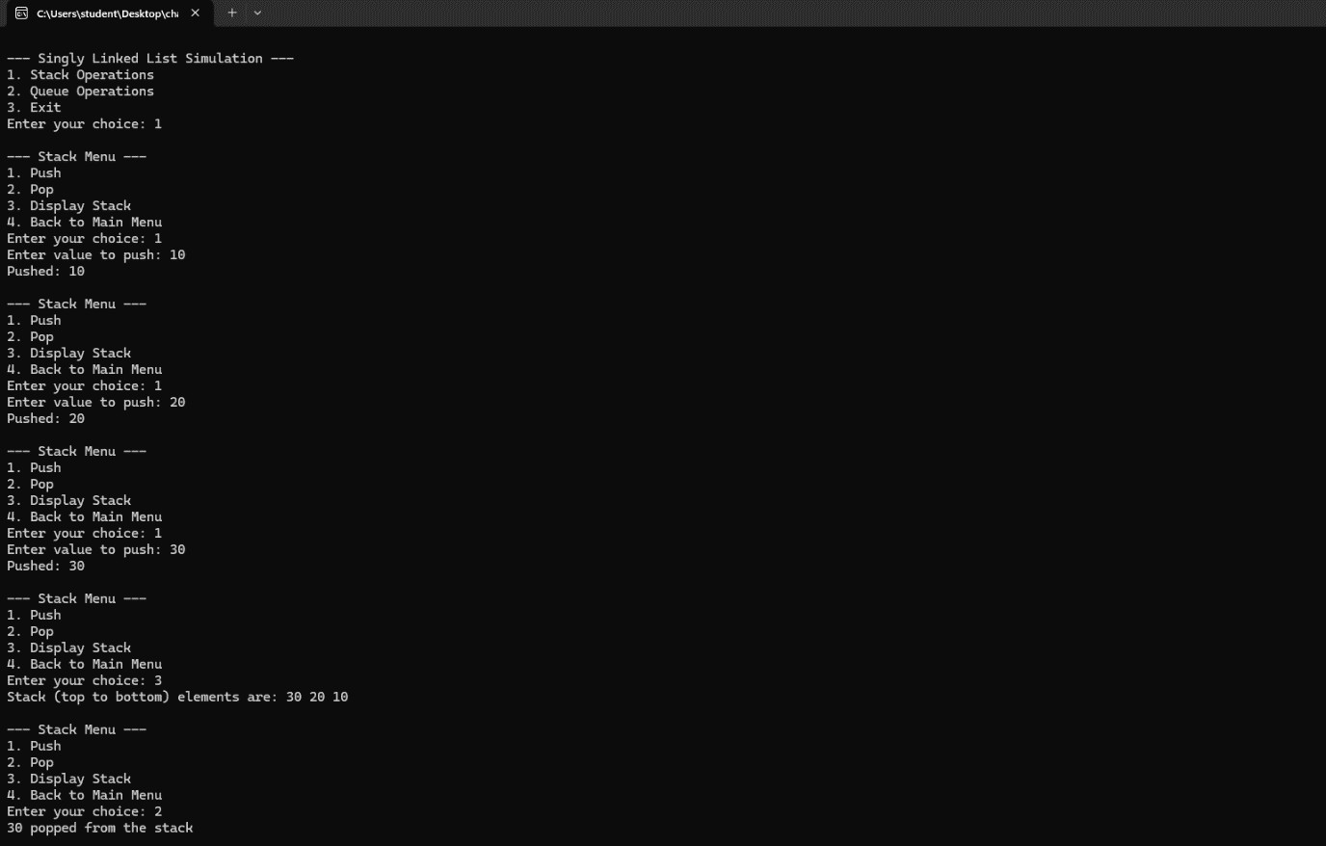
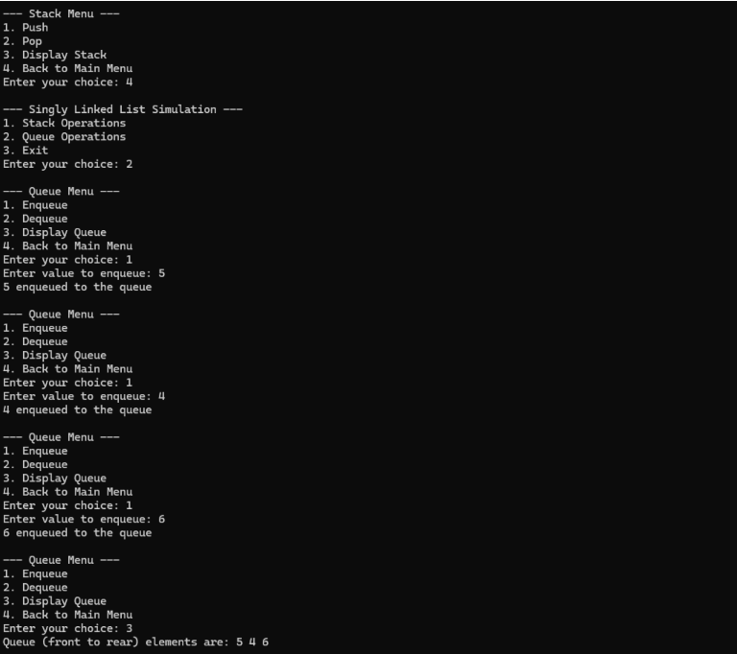
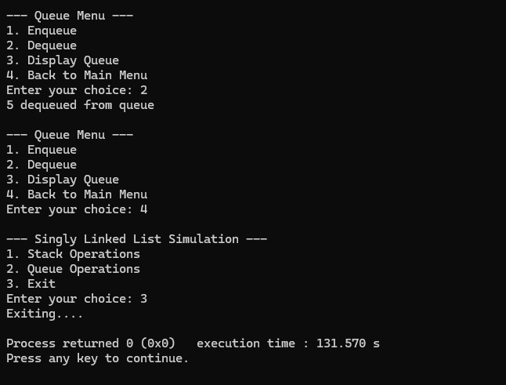

Lab Program 7a:
WAP to Implement doubly link list with primitive operations a) Create a doubly linked list. b) Insert a new node to the left of the node. c) Delete the node based on a specific value d) Display the contents of the list.

#include <stdio.h>
#include <stdlib.h>

struct Node {
int data;
struct Node *prev, *next;
};

struct Node *head = NULL, *tail = NULL;

void createList(int n) {
int i, data;
struct Node *newNode;
for (i = 1; i <= n; i++) {
printf("Enter data for node %d: ", i);
scanf("%d", &data);
newNode = (struct Node*)malloc(sizeof(struct Node));
newNode->data = data;
newNode->prev = newNode->next = NULL;
if (head == NULL) {
head = tail = newNode;
} else {
tail->next = newNode;
newNode->prev = tail;
tail = newNode;
}
}
}

void insertAtFront(int data) {
struct Node *newNode = (struct Node*)malloc(sizeof(struct Node));
newNode->data = data;
newNode->prev = NULL;
newNode->next = head;
if (head == NULL)
head = tail = newNode;
else {
head->prev = newNode;
head = newNode;
}
printf("Inserted %d at front\n",data);
}

void insertAtEnd(int data) {
struct Node *newNode = (struct Node*)malloc(sizeof(struct Node));
newNode->data = data;
newNode->next = NULL;
newNode->prev = tail;
if (tail == NULL)
head = tail = newNode;
else {
tail->next = newNode;
tail = newNode;
}
printf("Inserted %d at end\n",data);
}

void insertAtPosition(int data, int pos) {
int i;
struct Node *newNode, *temp = head;
if (pos == 1) {
insertAtFront(data);
return;
}
newNode = (struct Node*)malloc(sizeof(struct Node));
newNode->data = data;
for (i = 1; i < pos - 1 && temp != NULL; i++)
temp = temp->next;
if (temp == NULL || temp->next == NULL) {
insertAtEnd(data);
return;
}
newNode->next = temp->next;
newNode->prev = temp;
temp->next->prev = newNode;
temp->next = newNode;
printf("Inserted %d at position %d\n",data,pos);
}

void deleteAtFront() {
struct Node *temp;
if (head == NULL) {
printf("List is empty!\n");
return;
}
temp = head;
head = head->next;
if (head != NULL)
head->prev = NULL;
else
tail = NULL;
printf("Deleted %d at front\n",temp->data);
free(temp);
}

void deleteAtEnd() {
struct Node *temp;
if (tail == NULL) {
printf("List is empty!\n");
return;
}
temp = tail;
tail = tail->prev;
if (tail != NULL)
tail->next = NULL;
else
head = NULL;
printf("Deleted %d at end\n",temp->data);
free(temp);
}

void deleteByValue(int value) {
struct Node *temp = head;
if (head == NULL) {
printf("List is empty!\n");
return;
}
while (temp != NULL && temp->data != value)
temp = temp->next;
if (temp == NULL) {
printf("Value not found!\n");
return;
}
if (temp == head)
deleteAtFront();
else if (temp == tail)
deleteAtEnd();
else {
temp->prev->next = temp->next;
temp->next->prev = temp->prev;
printf("Deleted %d \n",temp->data);
free(temp);
}
}

void search(int value) {
struct Node *temp = head;
int pos = 1;
while (temp != NULL) {
if (temp->data == value) {
printf("Value %d found at position %d\n", value, pos);
return;
}
temp = temp->next;
pos++;
}
printf("Value %d not found in the list.\n", value);
}

void displayForward() {
struct Node *temp = head;
printf("List (Forward): ");
while (temp != NULL) {
printf("%d <-> ", temp->data);
temp = temp->next;
}
printf("NULL\n");
}

void displayBackward() {
struct Node *temp = tail;
printf("List (Backward): ");
while (temp != NULL) {
printf("%d <-> ", temp->data);
temp = temp->prev;
}
printf("NULL\n");
}

int main() {
int choice, n, data, pos, value;

printf("Enter number of nodes to create: ");
scanf("%d", &n);
createList(n);

while (1) {
printf("\n--- DOUBLY LINKED LIST MENU ---\n");
printf("1. Display Forward\n");
printf("2. Display Backward\n");
printf("3. Insert at Front\n");
printf("4. Insert at End\n");
printf("5. Insert at Position\n");
printf("6. Delete at Front\n");
printf("7. Delete at End\n");
printf("8. Delete by Value\n");
printf("9. Search\n");
printf("10. Exit\n");
printf("Enter your choice: ");
scanf("%d", &choice);

switch (choice) {

case 1:
displayForward();
break;

case 2:
displayBackward();
break;

case 3:
printf("Enter data to insert at front: ");
scanf("%d", &data);
insertAtFront(data);
break;

case 4:
printf("Enter data to insert at end: ");
scanf("%d", &data);
insertAtEnd(data);
break;

case 5:
printf("Enter data: ");
scanf("%d", &data);
printf("Enter position: ");
scanf("%d", &pos);
insertAtPosition(data, pos);
break;

case 6:
deleteAtFront();
break;

case 7:
deleteAtEnd();
break;

case 8:
printf("Enter value to delete: ");
scanf("%d", &value);
deleteByValue(value);
break;

case 9:
printf("Enter value to search: ");
scanf("%d", &value);
search(value);
break;

case 10:
printf("Exiting program...\n");
exit(0);

default:
printf("Invalid choice! Try again.\n");
}
}

return 0;
}

Output:
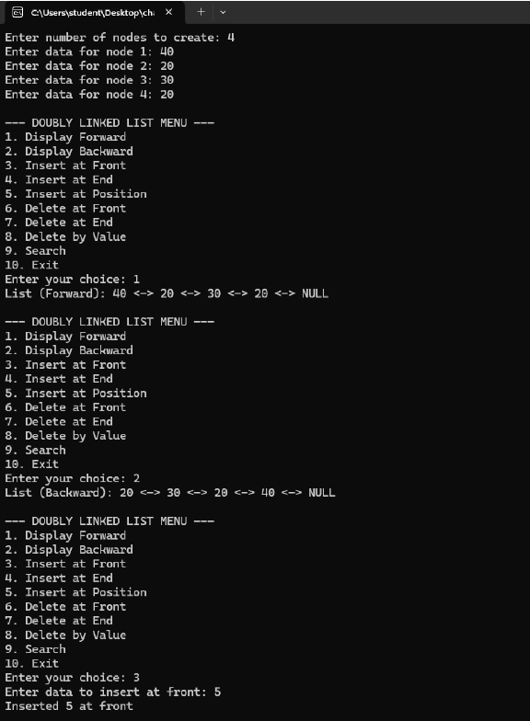
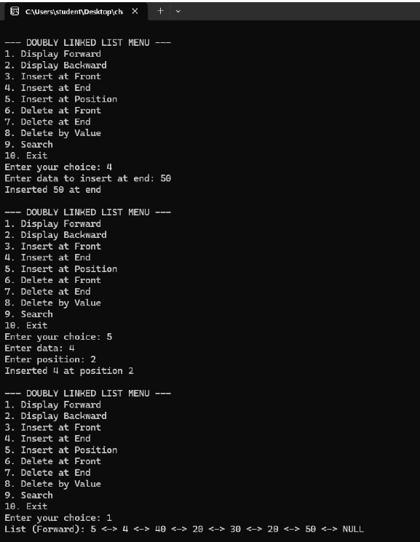
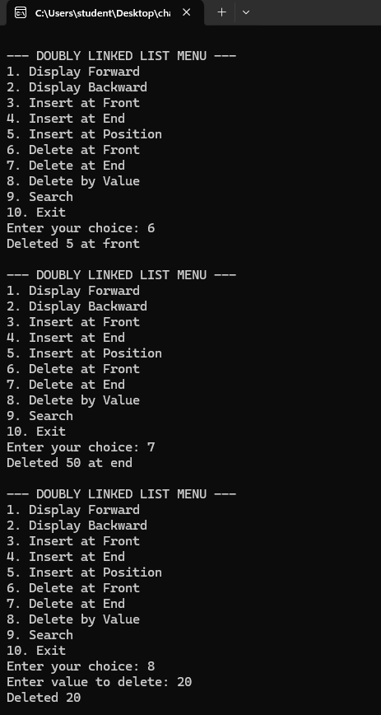
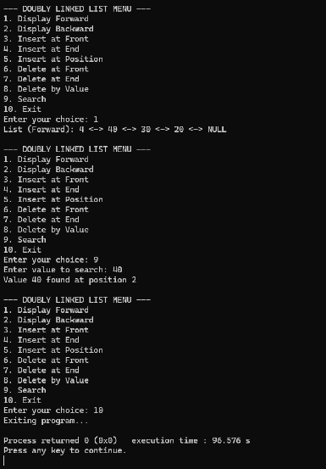

Lab Program 7b:
Leetcode platform

bool hasCycle(struct ListNode *head) {
// If list is empty or has only one node, cycle is impossible
if (head == NULL || head->next == NULL)
return false;

struct ListNode *slow = head;
struct ListNode *fast = head;

// Move fast pointer by 2 and slow pointer by 1
while (fast != NULL && fast->next != NULL) {
slow = slow->next;
fast = fast->next->next;

// If slow and fast meet, there is a cycle
if (slow == fast)
return true;
}

// Fast reached the end → no cycle
return false;
}

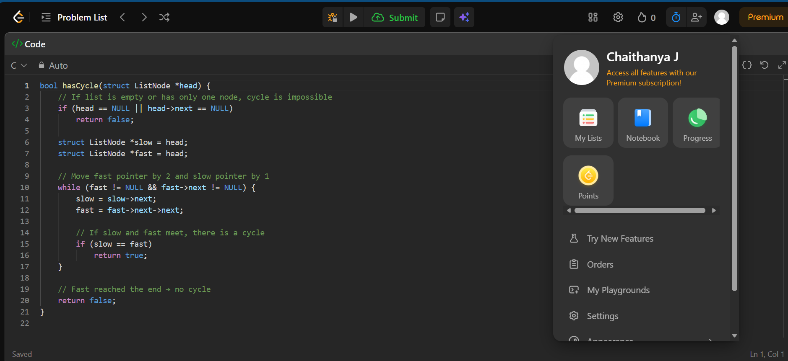

Output:

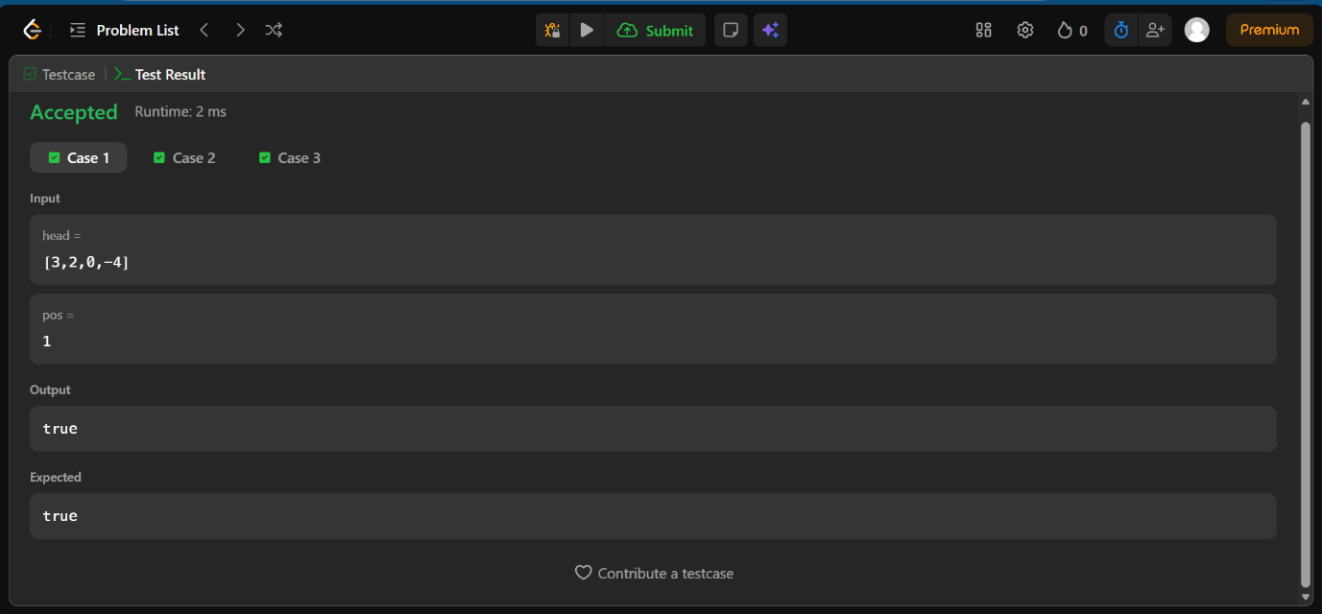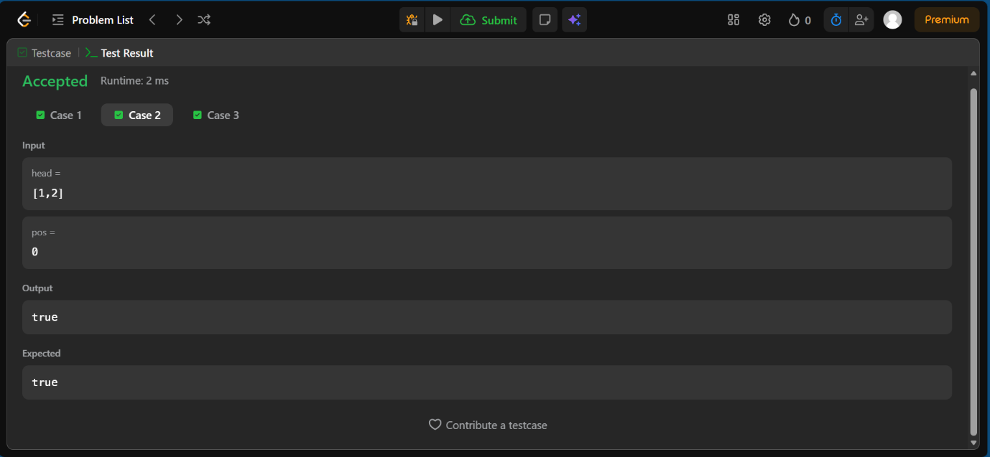
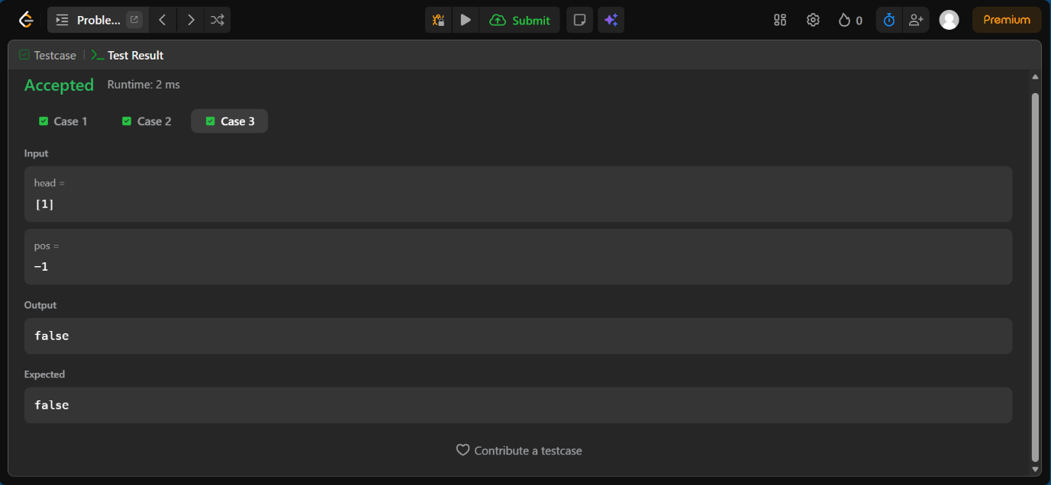

Lab Program 8:
Write a program
a) To construct a binary Search tree.
b) To traverse the tree using all the methods i.e., in-order, preorder and post order .
c) To display the elements in the tree.

#include <stdio.h>
#include <stdlib.h>

struct Node {
int data;
struct Node *left, *right;
};

struct Node* createNode(int value) {
struct Node *newNode = (struct Node*)malloc(sizeof(struct Node));
newNode->data = value;
newNode->left = newNode->right = NULL;
return newNode;
}

struct Node* insert(struct Node *root, int value) {
if (root == NULL)
return createNode(value);

if (value < root->data)
root->left = insert(root->left, value);
else if (value > root->data)
root->right = insert(root->right, value);

return root;
}

/* Inorder Traversal: Left -> Root -> Right */
void inorder(struct Node *root) {
if (root == NULL)
return;
inorder(root->left);
printf("%d ", root->data);
inorder(root->right);
}

/* Preorder Traversal: Root -> Left -> Right */
void preorder(struct Node *root) {
if (root == NULL)
return;
printf("%d ", root->data);
preorder(root->left);
preorder(root->right);
}

/* Postorder Traversal: Left -> Right -> Root */
void postorder(struct Node *root) {
if (root == NULL)
return;
postorder(root->left);
postorder(root->right);
printf("%d ", root->data);
}

void display(struct Node *root) {
printf("BST Elements (Inorder): ");
inorder(root);
printf("\n");
}

int main() {
struct Node *root = NULL;
int choice, value;

while (1) {
printf("\n--- Binary Search Tree Menu ---\n");
printf("1. Insert into BST\n");
printf("2. In-order Traversal\n");
printf("3. Pre-order Traversal\n");
printf("4. Post-order Traversal\n");
printf("5. Display BST\n");
printf("6. Exit\n");
printf("Enter choice: ");
scanf("%d", &choice);

switch (choice) {
case 1:
printf("Enter value to insert: ");
scanf("%d", &value);
root = insert(root, value);
break;

case 2:
printf("In-order Traversal: ");
inorder(root);
printf("\n");
break;

case 3:
printf("Pre-order Traversal: ");
preorder(root);
printf("\n");
break;

case 4:
printf("Post-order Traversal: ");
postorder(root);
printf("\n");
break;

case 5:
display(root);
break;

case 6:
printf("Exiting....");
exit(0);

default:
printf("Invalid choice! Try again.\n");
}
}

return 0;
}

Output:
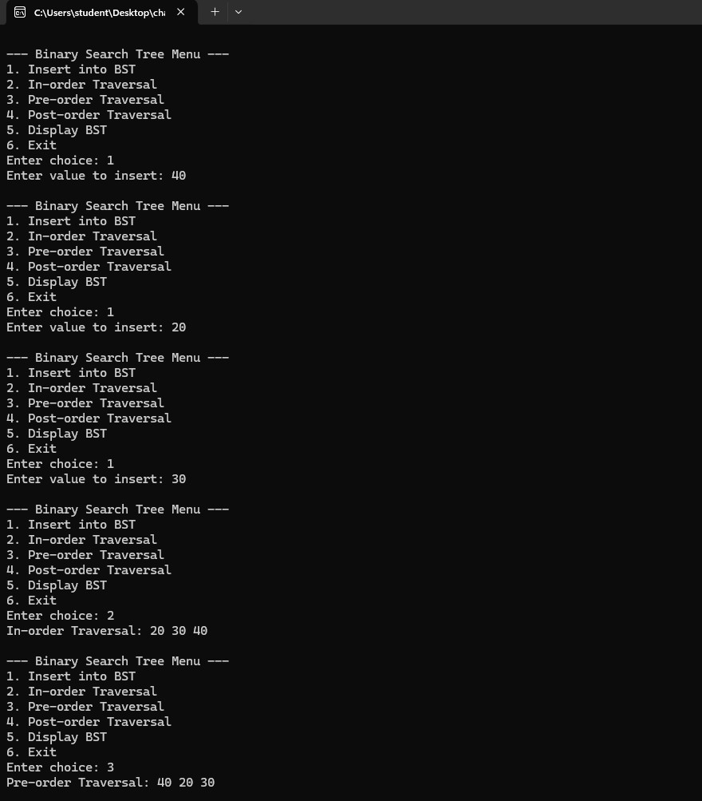
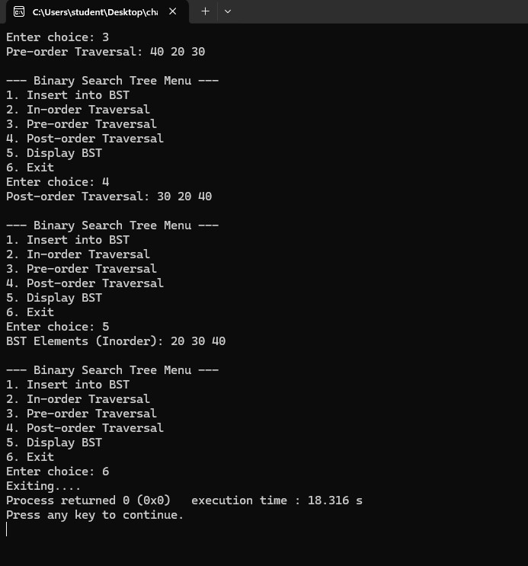

Lab Program 8b:
Leetcode platform

struct TreeNode* mergeTrees(struct TreeNode* root1, struct TreeNode* root2) {
if (root1 == NULL) return root2; // If first is null, use second
if (root2 == NULL) return root1; // If second is null, use first

// Both nodes exist: sum their values
root1->val += root2->val;

// Recursively merge left and right subtrees
root1->left = mergeTrees(root1->left, root2->left);
root1->right = mergeTrees(root1->right, root2->right);

return root1; // Return the merged tree
}

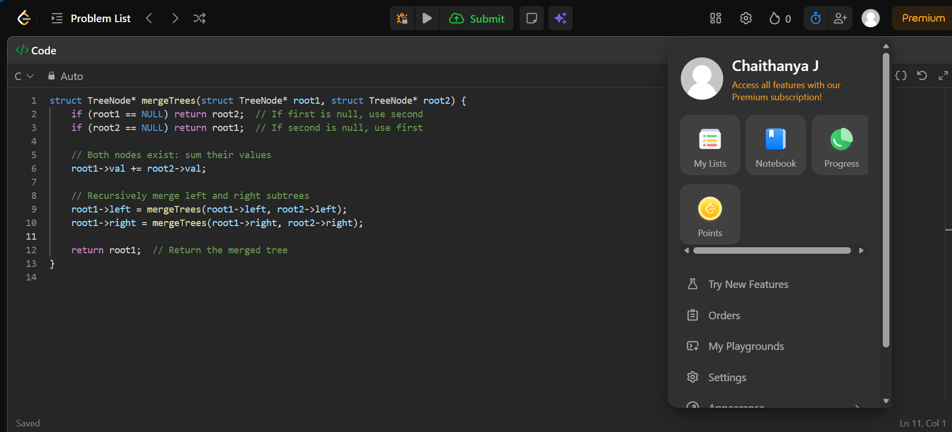

Output:

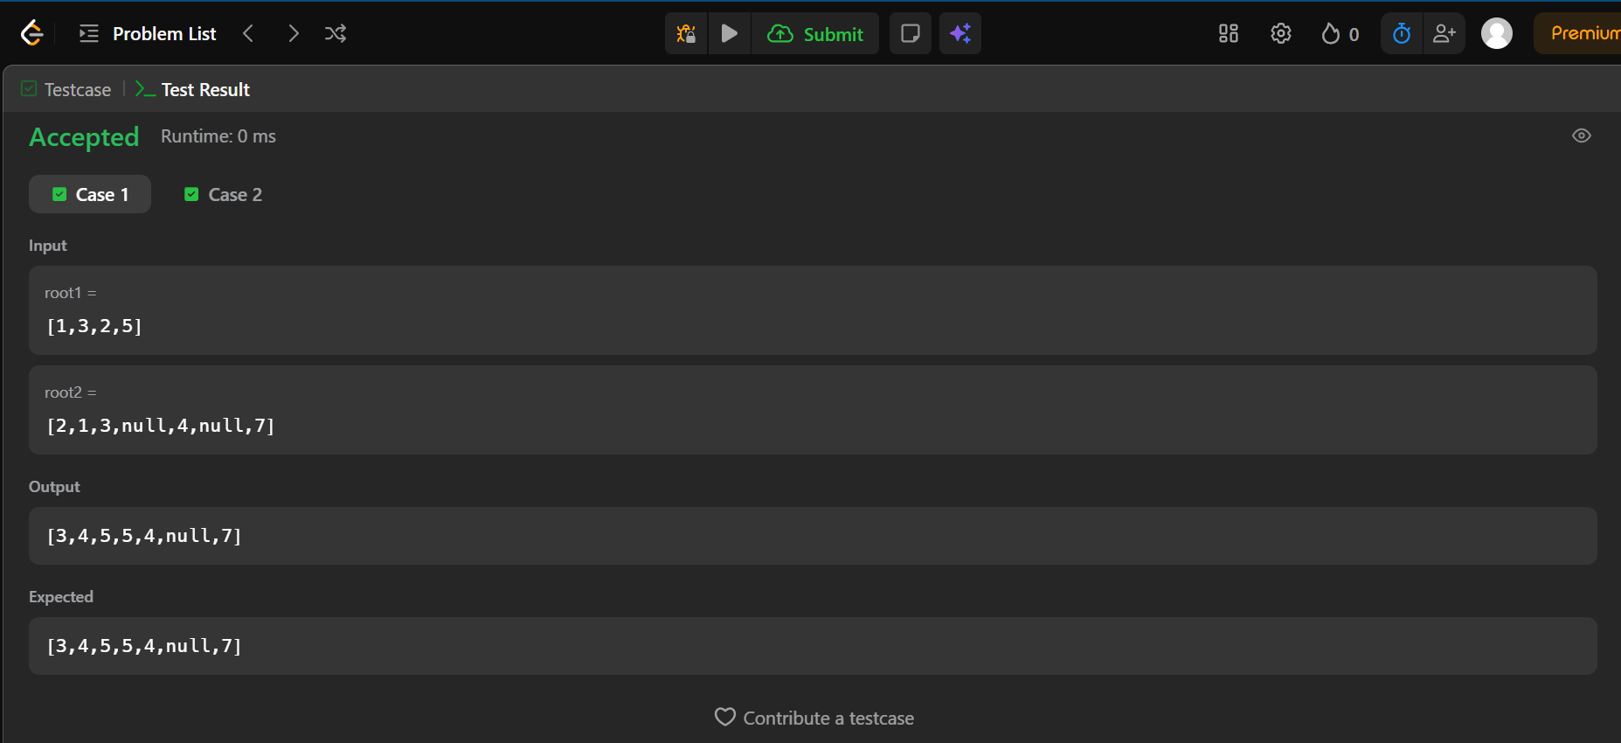

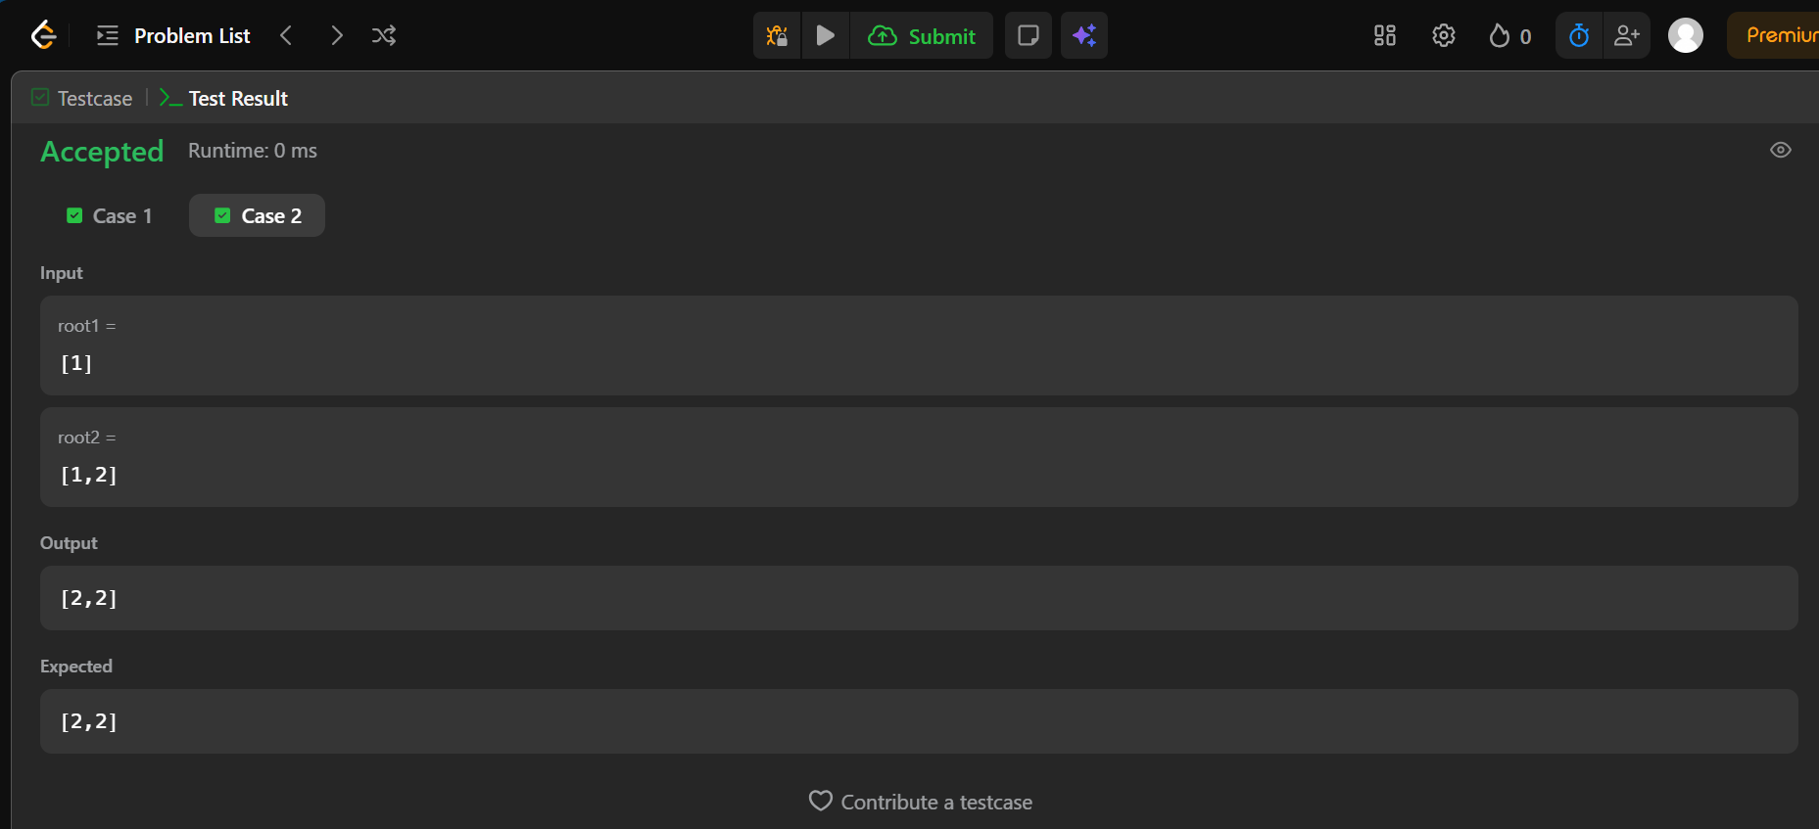

Lab Program 9a:
Write a program to traverse a graph using BFS method.

#include <stdio.h>

int graph[20][20], visited[20], n;

void BFS(int start) {
int queue[20], front = 0, rear = 0;

visited[start] = 1;
queue[rear++] = start;

while (front < rear) {
int node = queue[front++];
printf("%d ", node);

for (int i = 0; i < n; i++) {
if (graph[node][i] == 1 && !visited[i]) {
visited[i] = 1;
queue[rear++] = i;
}
}
}
}

int main() {
int start;

printf("Enter number of vertices: ");
scanf("%d", &n);

printf("Enter adjacency matrix:\n");
for (int i = 0; i < n; i++)
for (int j = 0; j < n; j++)
scanf("%d", &graph[i][j]);

for (int i = 0; i < n; i++)
visited[i] = 0;

printf("Enter starting vertex: ");
scanf("%d", &start);

printf("BFS Traversal: ");
BFS(start);

return 0;
}

Output:
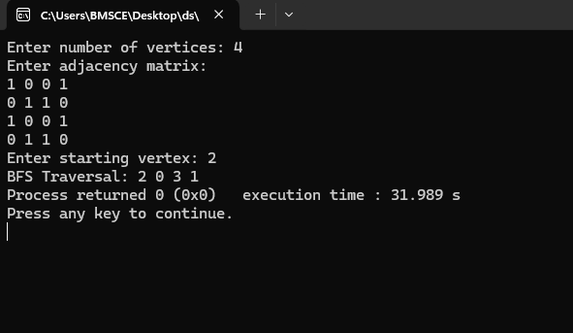

Lab Program 9b:
Write a program to check whether given graph is connected or not using DFS method.

#include <stdio.h>

#define MAX 10

int visited[MAX];
int adj[MAX][MAX];
int n;

// DFS function
void DFS(int v) {
visited[v] = 1;
printf("%d ", v);

for (int i = 0; i < n; i++) {
if (adj[v][i] == 1 && !visited[i]) {
DFS(i);
}
}
}

int main() {
printf("Enter number of vertices: ");
scanf("%d", &n);

printf("Enter adjacency matrix:\n");
for (int i = 0; i < n; i++) {
for (int j = 0; j < n; j++) {
scanf("%d", &adj[i][j]);
}
}

// Initialize visited array
for (int i = 0; i < n; i++)
visited[i] = 0;

printf("DFS Traversal starting from vertex 0:\n");
DFS(0);

return 0;
}

Output:
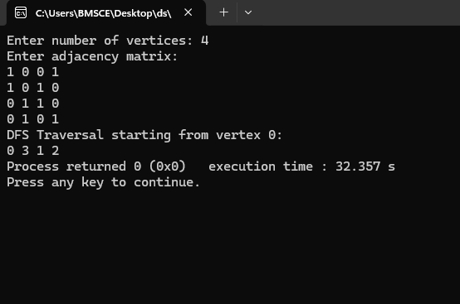

Lab Program 10:
Given a File of N employee records with a set K of Keys(4 digit) which uniquely determine the records in file F. 10 5 10 Assume that file F is maintained in memory by a Hash Table (HT) of m memory locations with L as the set of memory addresses (2-digit) of locations in HT. Let the keys in K and addresses in L are integers. Design and develop a Program in C that uses Hash function H: K -> L as H(K)=K mod m (remainder method), and implement hashing technique to map a given key K to the address space L. Resolve the collision (if any) using linear probing.

#include <stdio.h>

#define MAX 20

int hashtable[MAX];
int m;

/* Function to insert key using Linear Probing */
void insert(int key)
{
int index = key % m;

if (hashtable[index] == -1)
{
hashtable[index] = key;
}
else
{
int i = 1;
while (hashtable[(index + i) % m] != -1)
{
i++;
}
hashtable[(index + i) % m] = key;
}
}

/* Function to display hash table */
void display()
{
printf("\nHash Table:\n");
for (int i = 0; i < m; i++)
{
if (hashtable[i] != -1)
printf("Address %d : %d\n", i, hashtable[i]);
else
printf("Address %d : Empty\n", i);
}
}

int main()
{
int n, key;

printf("Enter size of hash table: ");
scanf("%d", &m);

printf("Enter number of employee records: ");
scanf("%d",&n);

// Initialize hash table
for (int i = 0; i < m; i++)
hashtable[i] = -1;

printf("Enter %d employee keys(4-digit):\n", n);
for (int i = 0; i < n; i++)
{
scanf("%d", &key);
insert(key);
}

display();

return 0;
}

Output:
